**Enterprise Resource Planning**

**Training User Manual**

**VERSION 12.0.0**

**Login & Change Password**

**Index**

|  |  |
| --- | --- |
| **About** | **Page No.** |
| * Login | **03** |
| * Select Business | **04** |
| * Main Menu | **05** |
| * Change Password | **06** |
|  |  |
|  |  |

# login

All users need to login to start using the ERP system. After login the ERP system opens for selecting your desired business.

LOGIN

|  |  |
| --- | --- |
| **Step 1** | Open internet Explorer |
| **Step 2** | Go to <http://182.160.99.210:210/zab/login> (182.160.99.210 = PC IP) |
| **Step 3** | Bookmark this site for later use |
| **Result** | Open SELECT BUSINESS page |

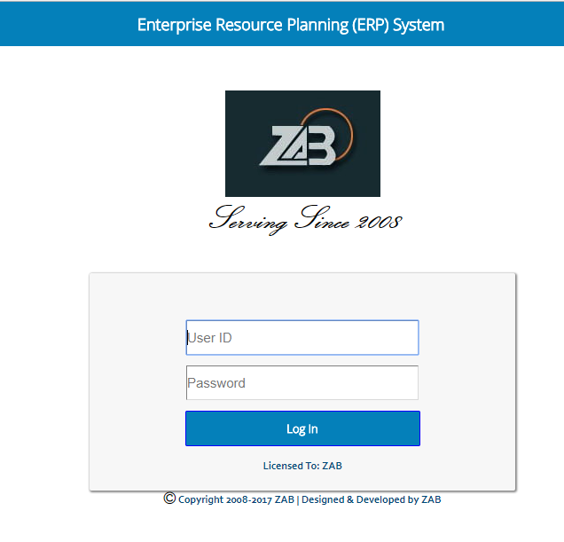

# Select business

All users need to select their desired business to start using the ERP system. After selecting the ERP system opens all features that are assigned to the user.

SELECT BUSINESS

|  |  |
| --- | --- |
| **Step 1** | Click on the desired business |
| **Result** | Open ERP system |

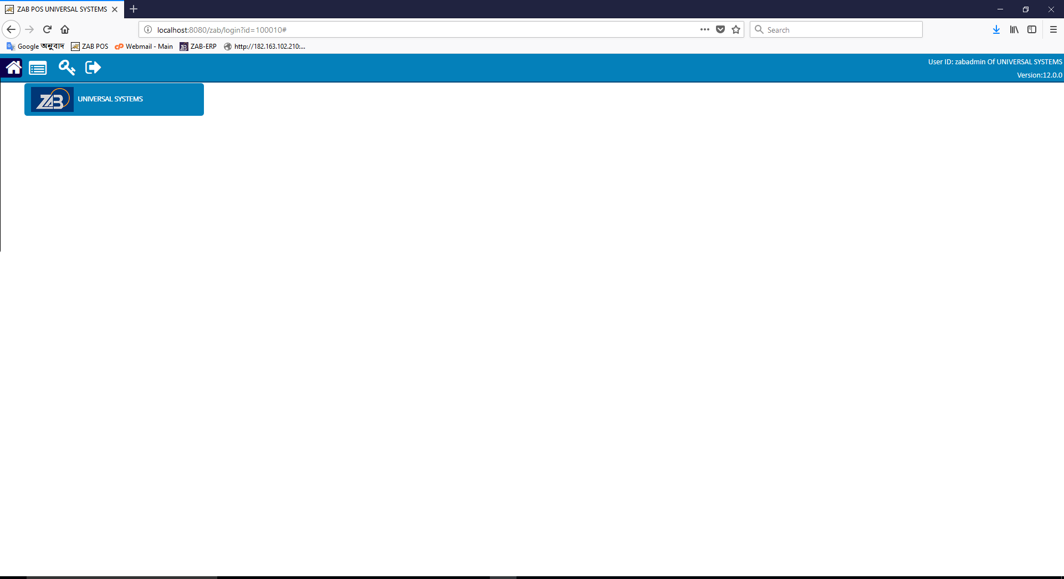

# Main Menu

|  |  |
| --- | --- |
| **Step 1** | Click on the Home Icon for Main Menu |

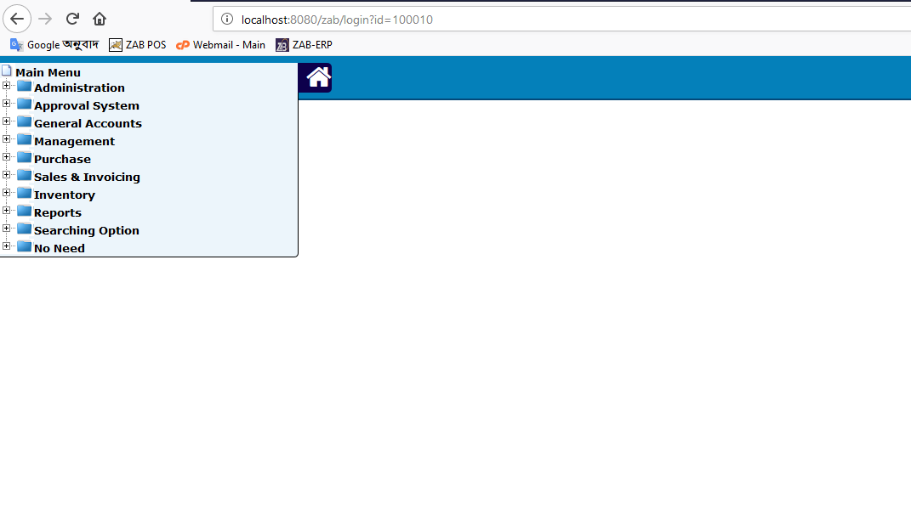

# Change password

|  |  |
| --- | --- |
| **Step 1** | Open System **>** Click on the Key Icon |
| **Step 2** | Fill in old password, and new password |
| **Step 3** | Confirm new password |
| **Step 4** | Click **Change Password** |
| **Result** | Password changed |

